1. First, we installed Zod. So, why Zod? Normal typescript is fine and all. But it works only on compile time. When we are in run-time, the types are gone. So Zod fixed this. It also centralizes the types and works on runtime. So, we installed Zod using:



1. Now, we made new validators file in the LIB.

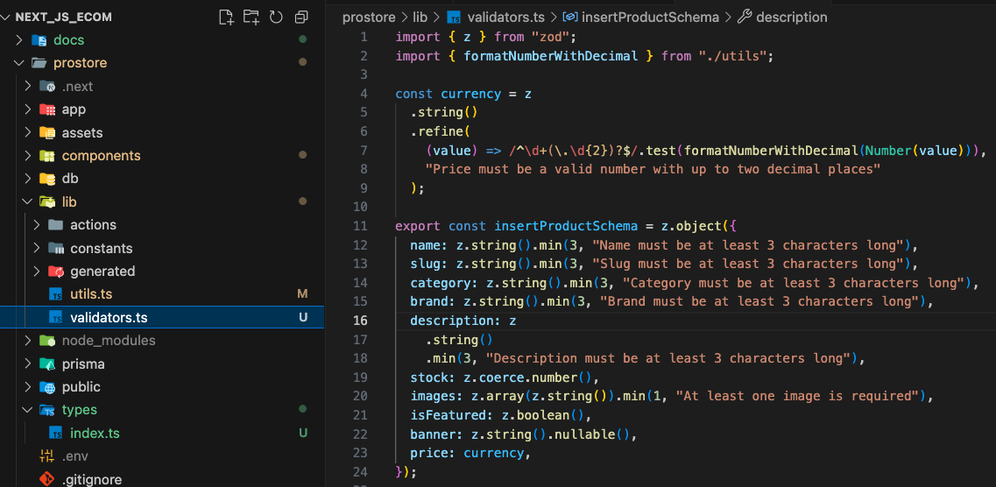

* Here the currency is made to be more precise. We are checking numbers to be 49.99 and 48.90 instead of just being 48.9
* Also, we made a new utility function to test it

1. Now, we made new types folder in the root

And used the schema we created using Zod. The reason we didn't use Zod for id, rating, and createdAt in your Product type is because these fields are not part of the data we are inserting or validating from an external source (like a form or a user). Instead, they are fields that are typically generated and managed by our backend system.

And used it wherever we were using any. Using any destroys the purpose of typescript



